AI QUIZ GENERATOR

Introduction
The AI Quiz Generator is a Python-based application developed to conduct quizzes through the terminal or command prompt. The system asks multiple-choice questions to users, checks whether the answers are correct, calculates the score, and displays the final result after the completion of the quiz.
This project helps beginners understand Python programming concepts such as loops, conditional statements, functions, lists, dictionaries, and user input handling. The application provides an interactive learning experience and improves logical thinking skills.
Objective
The main objective of this project is to develop an interactive quiz application using Python programming language. The project aims to improve programming knowledge, logical thinking, and problem-solving skills.
Objectives of the project:
• To create a command-line quiz application
• To implement multiple-choice questions
• To validate user answers automatically
• To calculate and display scores
• To improve understanding of Python programming concepts

Technologies Used
Programming Language:
• Python
Development Tools:
• VS Code
• PyCharm
• IDLE
Platform:
• Terminal / Command Prompt
Python Concepts Used:
• Variables
• Lists
• Dictionaries
• Functions
• Loops
• Conditional Statements
• User Input Handling

System Design
The system is designed to work in a simple step-by-step process.
Working Flow:
1. Start the application
2. Display quiz questions
3. Accept answers from the user
4. Validate answers
5. Update score
6. Display final result
7. End the program
Modules in the System:
• Question Module
• User Input Module
• Validation Module
• Score Module
• Result Display Module

Implementation
The AI Quiz Generator is implemented using Python programming language. Questions are stored using dictionaries and lists. The application uses loops to display questions repeatedly and conditional statements to verify user answers.
Sample Code:
questions = [
{
"question": "Which loop is used for fixed iterations?",
"options": ["A. while", "B. for", "C. repeat", "D. loop"],
"answer": "B"
}
]
score = 0
for q in questions:
print(q["question"])
for option in q["options"]:
print(option)
user_answer = input("Enter your answer: ")
if user_answer.upper() == q["answer"]:
print("Correct Answer!")
score += 1
else:
print("Wrong Answer!")
print("Final Score:", score)

Output Screenshots
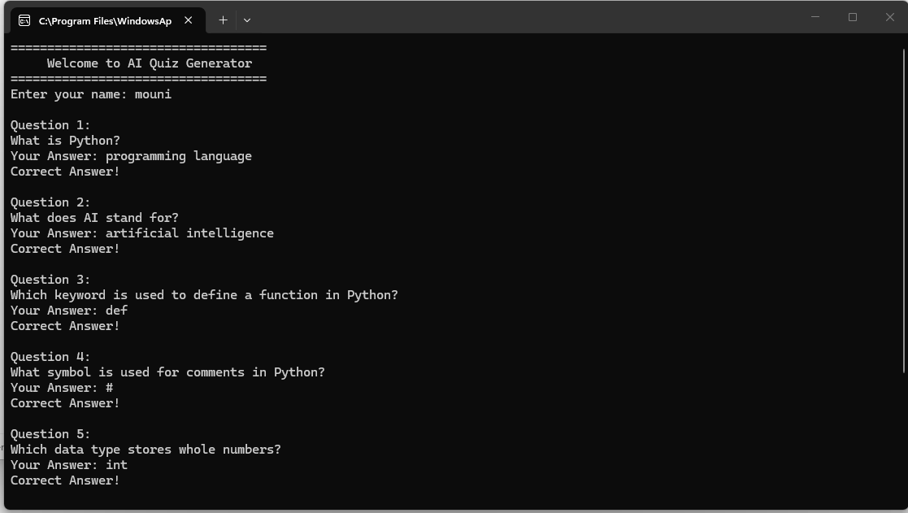
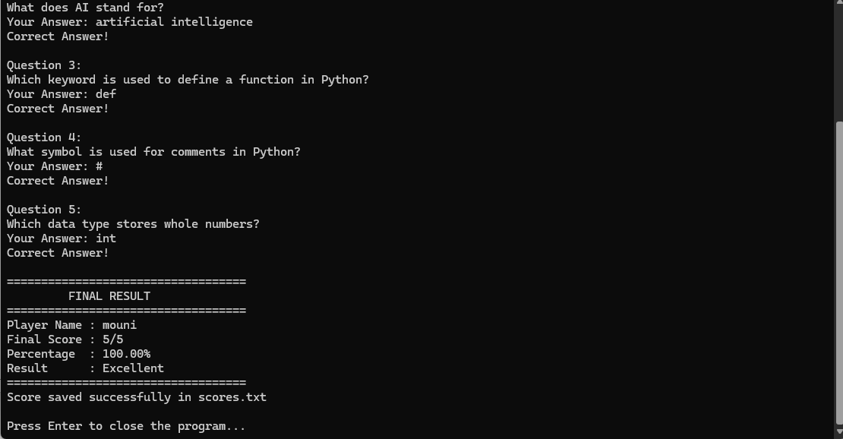
Optional features add to quiz screenshots
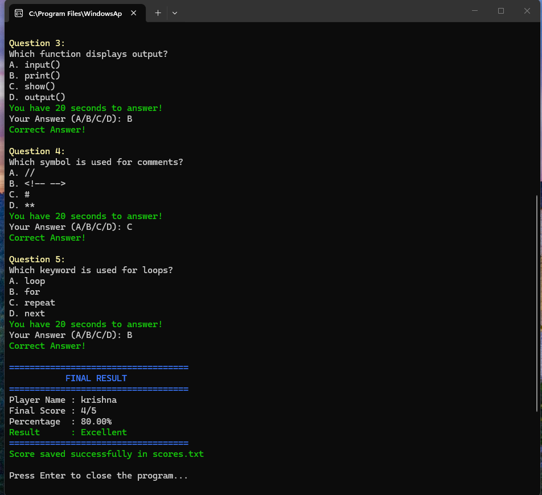

Advantages
• Beginner-friendly project
• Easy to understand and implement
• Improves logical thinking
• Provides interactive learning
• Enhances Python programming skills
• Can be expanded with advanced features

Conclusion
The AI Quiz Generator project successfully demonstrates the implementation of a quiz application using Python programming language. The project provides practical knowledge of loops, conditions, functions, and user interaction.
The application creates an interactive learning environment where users can answer quiz questions and receive immediate feedback. This project serves as an excellent learning experience for beginners and can be improved further by adding graphical interfaces, databases, timers, and online quiz features.

